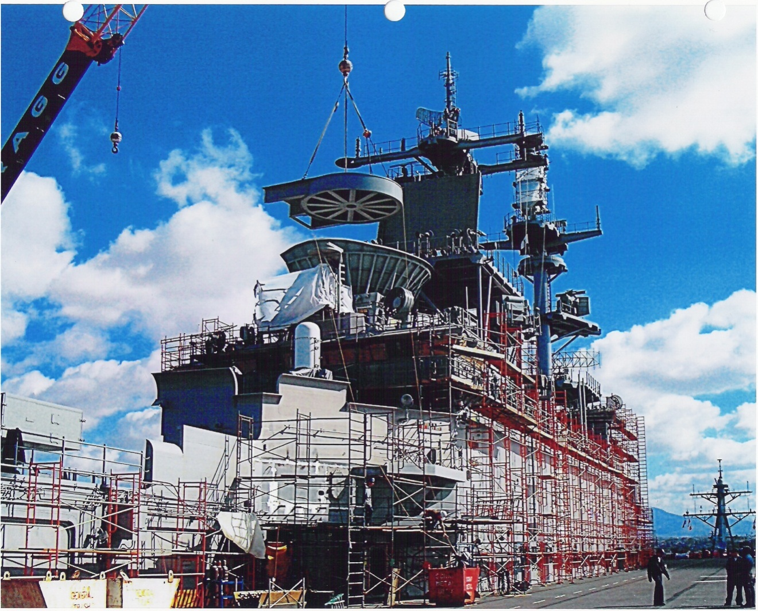  Courses Offered  Southcoast Welding Institute offers introductory courses and some advanced courses. To enroll in an advanced course, potential students must either pass the corresponding introductory course or take a practical welding pre-requisite test.  Introductory:  - Flux-Cored Arc Welding (FCAW) – MIG  - Gas Metal Arc Welding (GMAW) – MIG  - Gas Tungsten Arc Welding (GTAW) – TIG  Advanced:  - Gas Metal Arc Welding (GMAW) – MIG Advanced Aluminum w/ 5XXX Requirements  - Gas Tungsten Arc Welding (GTAW) – TIG Pipe | Who We Are  About Us  Southcoast Welding Institute is a Non-Accredited Post-Secondary Education Institution that strives to achieve growth, excellence, and superiority within the shipyard and construction industries. The goal is to be a proven leader in providing the best training and to be the best welding school in Southern California. Technical courses are specially designed to serve any individual skill level from beginning to advance welding and mirror applied principles. It is Southcoast Welding Institute’s endeavor to facilitate classroom theory and hands-on training to successfully accomplish vocational goals and career objectives. The institute provides the necessary trade skills and knowledge to pursue a profession in the welding industry.  Contact Us  Phone: (619) 429-1337  Email: info@southcoastwelding.net  Web: www.southcoastwelding.net  Southcoast Welding Institute  2591 Faivre St., #2  Chula Vista, CA 91911 | Southcoast Welding Institute  - A Division of Southcoast Welding & Manufacturing, LLC.
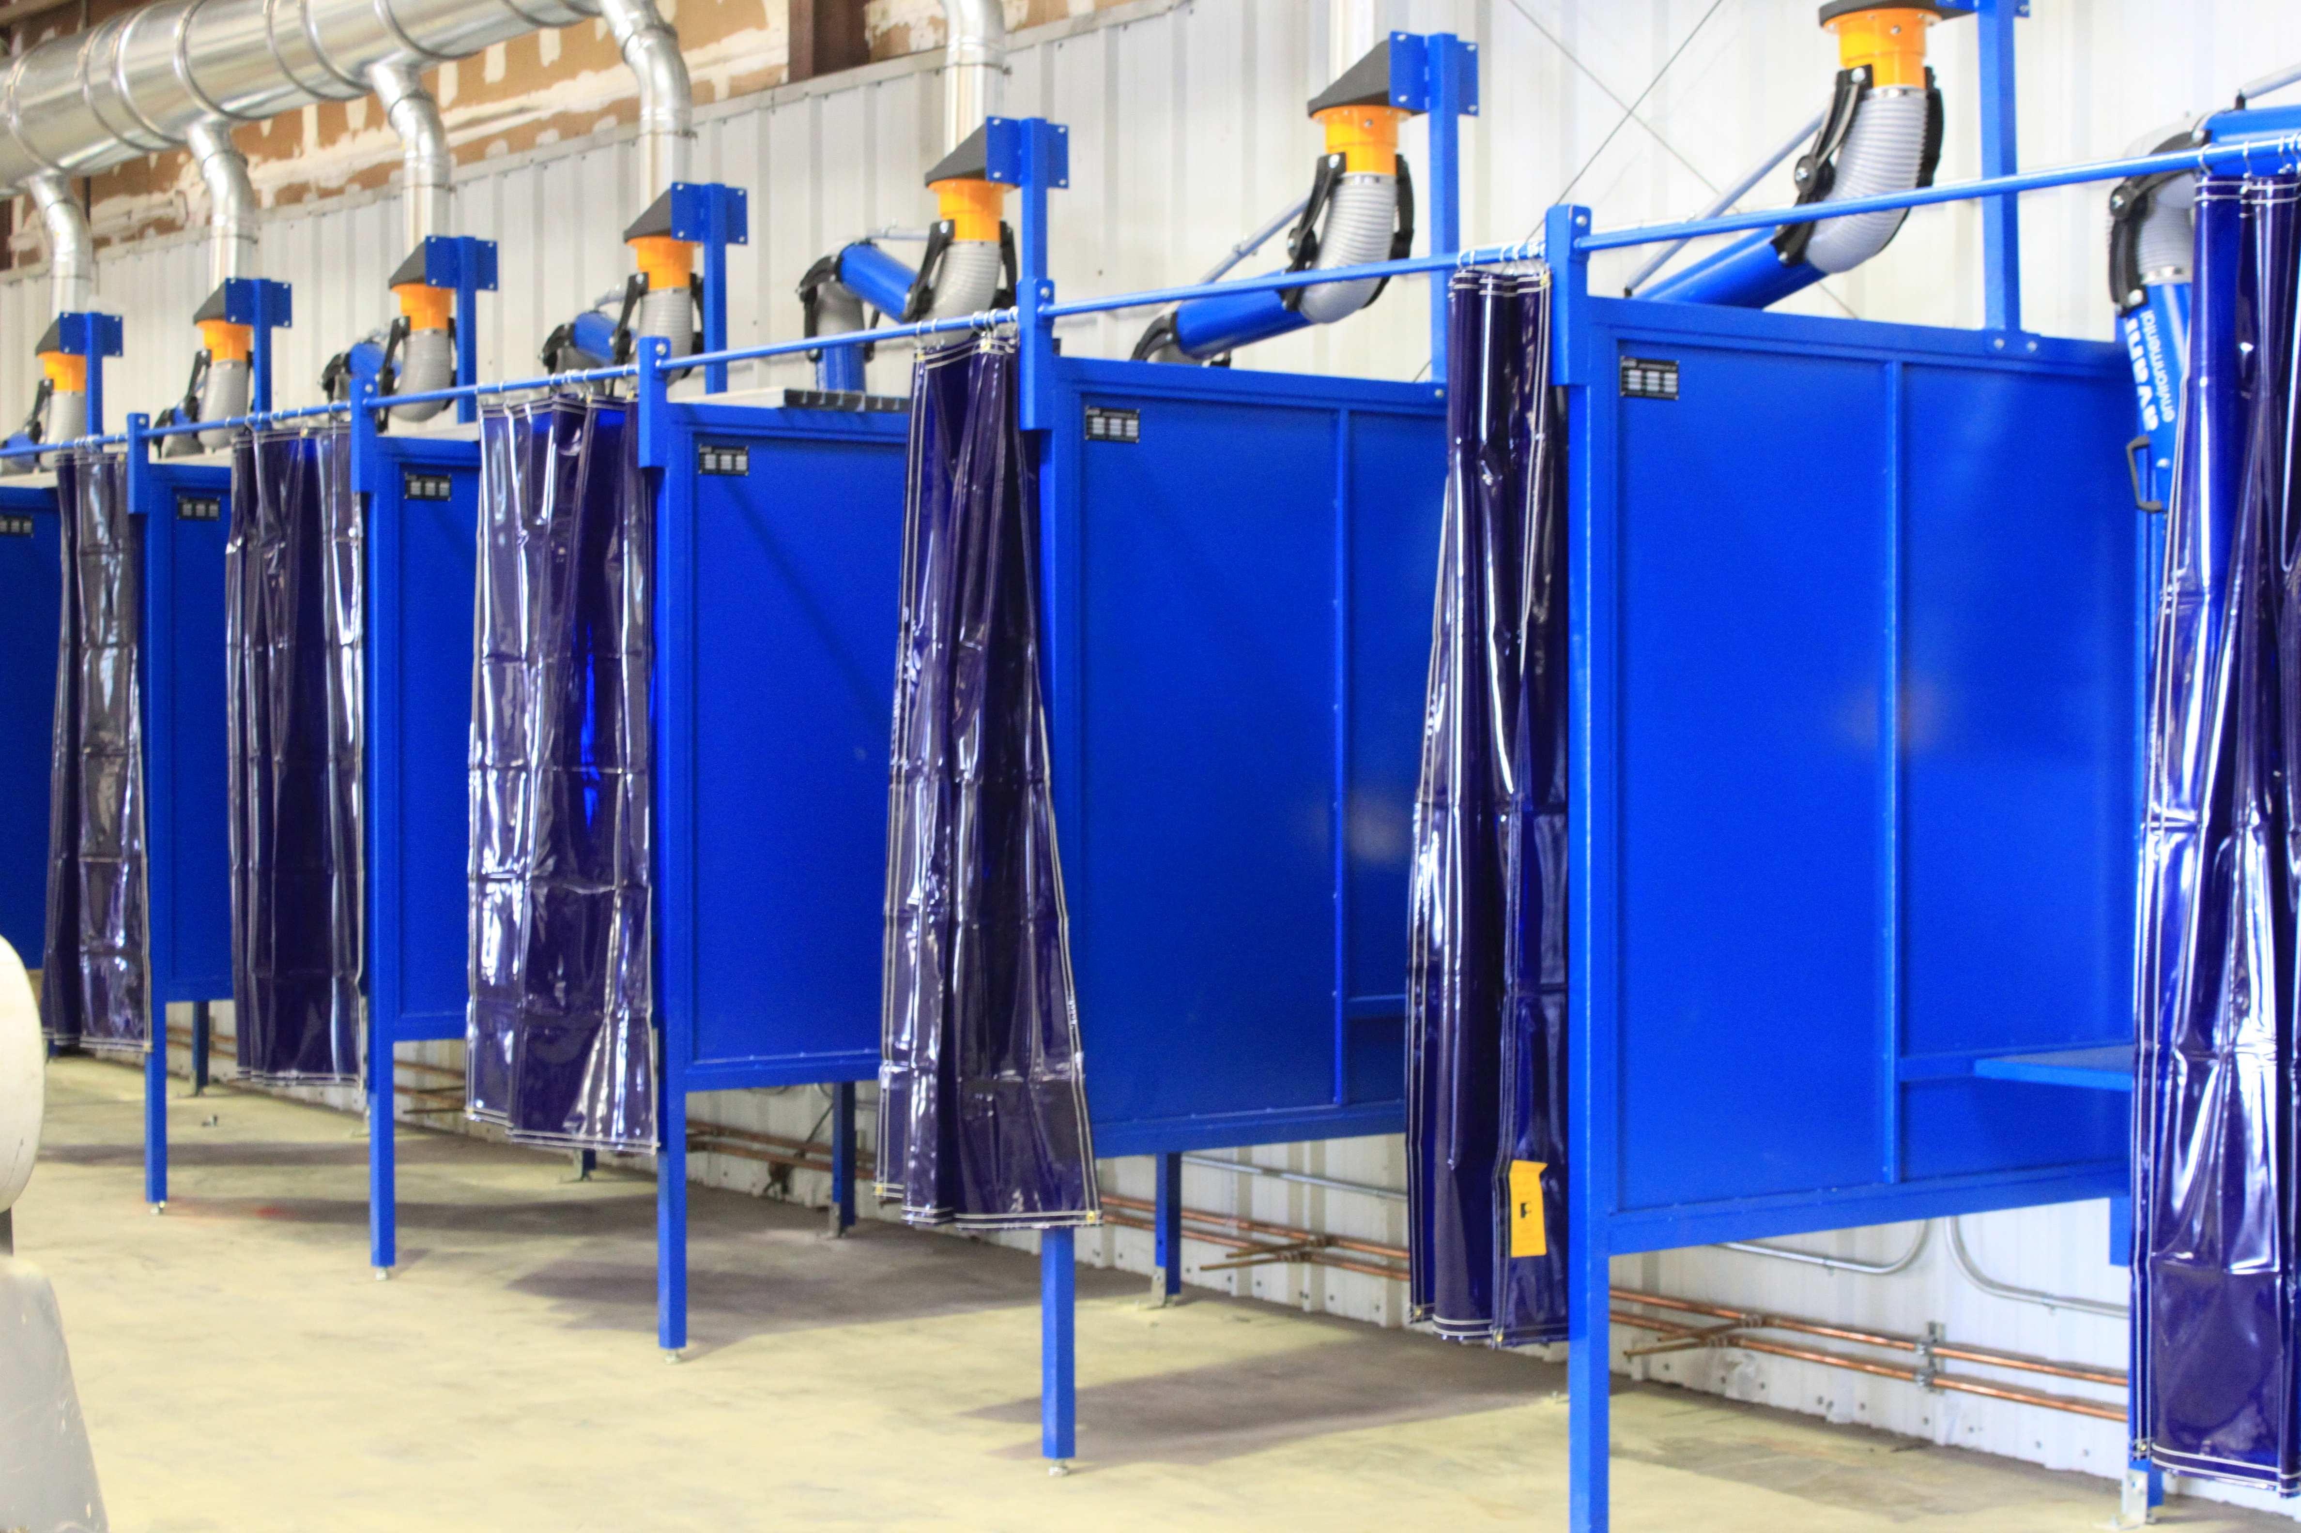  Figure: Welding Training Booths  Program Information  Course Details  The Introductory (FCAW, MIG Aluminum, TIG) and Advanced (TIG Pipe) courses are 120 hours long. The GMAW – MIG Advanced Aluminum course consists of 80 hours. The courses are scheduled Monday through Friday, 4 hours a day, with no classes on the weekends.  Spaces are limited and will be on a first come/first serve basis (20 trainees per class). There are two course times to help meet the needs of all individuals. Upon completing a course, students will receive a certificate of completion and a radiographic work & interpretation record with the results of the corresponding weld process. | Instructors  Southcoast Welding Institute instructors retain academic, experiential, and professional qualifications to teach. Also, the instructors have a minimum of thirty years work experience that supports the education and training for each of our courses offered.  Don’t Miss the Opportunity! Join Our School Today!  Mock-Up  Within the courses, students will use a mock-up, which is a model or replica of a ship compartment where students can simulate real life welding applications in restricted positions.  Course Materials  When enrolling into any of the courses, students will receive:  - Welding Hood  - Welding Jacket  - Welding Gloves  - Safety Glasses  - Ear Plugs  - Workbook  - Chipping Hammer (FCAW-MIG Only) | 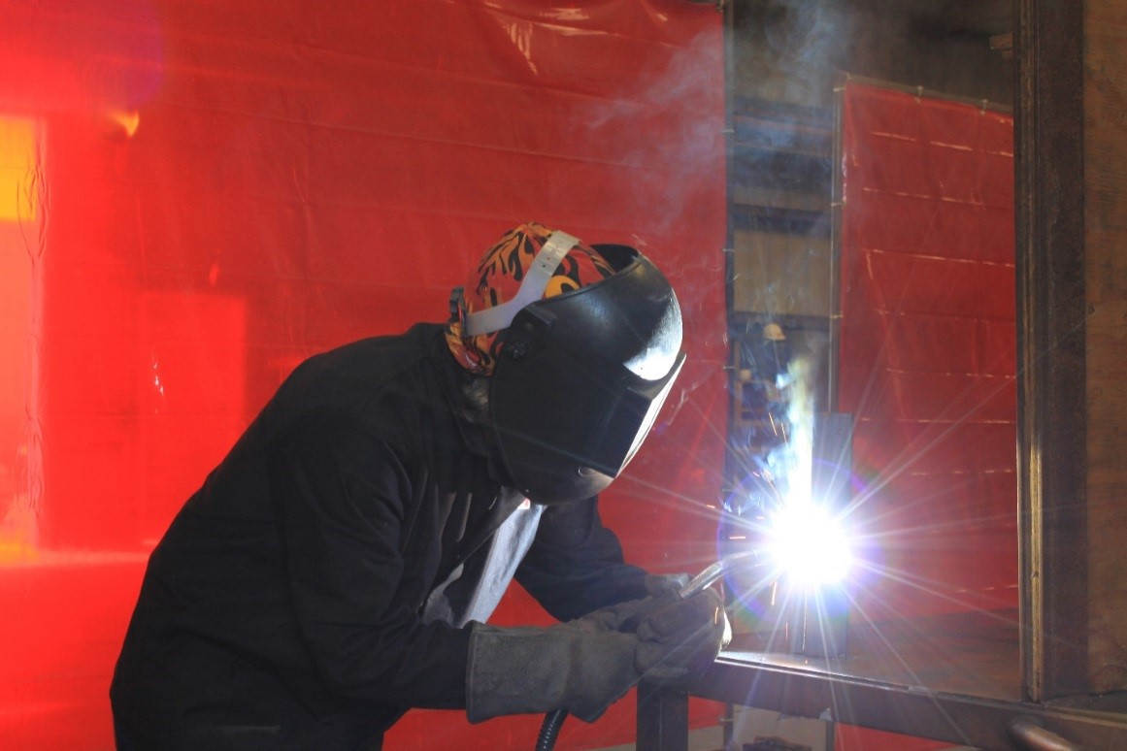  Figure: Flux-Cored Arc Welding (FCAW-MIG)  Job Assistance  Southcoast Welding Institute was founded on the principals of assisting students in seeking meaningful employment upon program completion. To be considered for assistance, students must complete the total amount of course hours, and present a good academic and behavioral status. Students may be given priority to apply with our parent-company, Southcoast Welding & Manufacturing, LLC., when there are positions available.  Southcoast Welding Institute will make every conceivable effort with job assistance.

